Chapter 7 Elements
extra worksheet 3: Atomic symbols and electron configurations

Answers
1
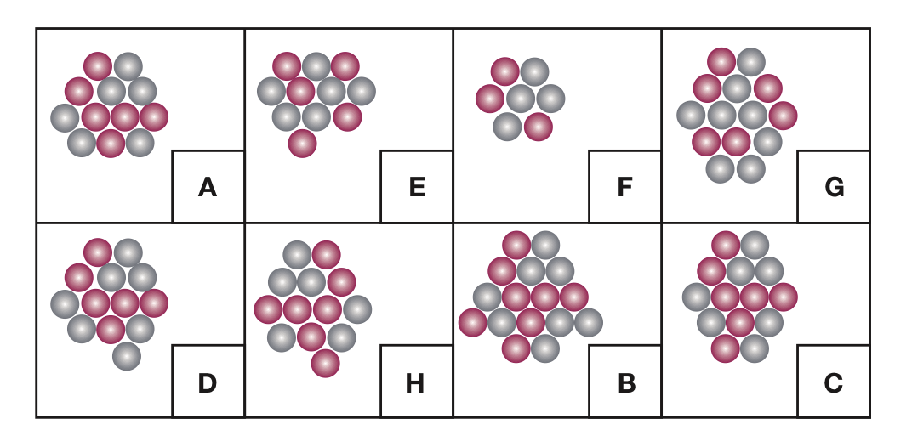
2

3 It is impossible to have a mass number that is smaller than the atomic number as the mass number is the atomic number plus the number of neutrons.
The chemical symbol for calcium must start with a capital letter (Ca).
The atomic number of helium is always 2.
4


